Q3 – Engineer the hashCode–equals Contract 6MarksBloom’s Level: K4 – Analyse
Problem Context – Event Attendance De-duplication
A college fest records attendance by scanning student ID cards at several gates. Thesamestudent may be scanned more than once. The organisers store scans in a HashSet<Student>tokeep only unique students. A junior developer has written the Student class below.
class Student {
String regNo; String name;
Student(String regNo, String name) { this.regNo = regNo; this.name = name; }public boolean equals(Object o) {
if (!(o instanceof Student)) return false;
return regNo.equals(((Student) o).regNo);
}
// hashCode() is not overridden
}

Your Challenge
Instead of simply fixing the class, investigate how the contract between equals() and hashCode() affects hash-based collections.
Design:
1. One set of scans for which the HashSet appears to work correctly.
2. One set of scans deliberately designed to expose duplicate entries. 3. One additional test of your own (for example: changing regNo after insertion, or aTreeSet whose compareTo() is inconsistent with equals()).
Before executing each test, predict the size of the set and explain the reason for your prediction. Inquiry
Compare your prediction with the experimental result. Explain:
• Why the duplicates appear
• How HashSet uses hashCode() and equals() to locate an element
• What happens when a field used in hashCode() is changed after the object is added• How to correct the Student class and how to verify the correction
CSA09 – Programming in Java – Assignments CO1–CO5 | Page 3
Complete the Code
Run the program first without completing TODO 1 and record the output. Then complete TODO1and execute it again.

import java.util.HashSet;
import java.util.Set;
class Student {
private final String regNo;
private final String name;
Student(String regNo, String name) { this.regNo = regNo; this.name = name; }
@Override public boolean equals(Object o) {
if (this == o) return true;
if (!(o instanceof Student)) return false;
return regNo.equals(((Student) o).regNo);
}
// TODO 1: Override hashCode() so that it is consistent with equals()
@Override public String toString() { return regNo + " " + name; } }
public class Attendance {
public static void main(String[] args) {
Set<Student> present = new HashSet<>();
present.add(new Student("192311001", "Arun")); // scanned at Gate 1present.add(new Student("192311002", "Divya"));
present.add(new Student("192311001", "Arun")); // scanned again at Gate 3System.out.println("Unique students: " + present.size()); }
}

Expected output:
Unique students: 2

Record the output before completing TODO 1 and explain the difference. Alternative Concept and Complexity Analysis

If a TreeSet<Student> with a Comparator on regNo, or a HashMap<String, Student> keyedbyregNo, were used instead of HashSet<Student>, what would the de-duplication solutionbe?Analyse the time per scan (O(1) average versus O(log n)) and the space used for nuniquestudents in each structure.
Evidence Expected
Three deliberately designed tests, predictions before execution, observed set sizes, a correctedStudent class and a reasoned explanation of the contract.
Answer:

Q3 – HashSet and hashCode–equals Contract
Objective:
To investigate how HashSet identifies duplicate Student objects and understand the importance of implementing both equals() and hashCode().
Observation:
The experiment showed that adding the same object reference twice resulted in one entry. However, adding two separate Student objects with the same registration number could result in duplicate entries when hashCode() was not correctly implemented.
Correction:
The hashCode() method was implemented using the student's registration number:
@Override
public int hashCode() {
return Objects.hash(regNo);
}
After this correction, equal Student objects produced the same hash code, allowing HashSet to identify duplicates correctly.
Conclusion:
Both equals() and hashCode() must be implemented consistently when objects are stored in HashSet. HashSet provides average O(1) insertion and lookup, while TreeSet provides sorted storage with O(log n) insertion and lookup. HashMap is useful when students must be retrieved using their registration numbers.
Program:

import java.util.HashSet;
import java.util.Set;
import java.util.Objects;

// Student class with equals() but NO hashCode()
class BrokenStudent {
String regNo;
String name;

BrokenStudent(String regNo, String name) {
this.regNo = regNo;
this.name = name;
}

@Override
public boolean equals(Object obj) {
if (this == obj) return true;
if (!(obj instanceof BrokenStudent)) return false;

BrokenStudent other = (BrokenStudent) obj;
return regNo.equals(other.regNo);
}
}

// Correct Student class
class Student {
String regNo;
String name;

Student(String regNo, String name) {
this.regNo = regNo;
this.name = name;
}

@Override
public boolean equals(Object obj) {
if (this == obj) return true;
if (!(obj instanceof Student)) return false;

Student other = (Student) obj;
return regNo.equals(other.regNo);
}

// TODO 1 completed
@Override
public int hashCode() {
return Objects.hash(regNo);
}

@Override
public String toString() {
return regNo + " - " + name;
}
}

public class Main {

public static void main(String[] args) {

System.out.println("Q3 - HASHSET DUPLICATE TEST");
System.out.println("-----------------------------");

// TEST 1: Add the same object twice
Set<BrokenStudent> test1 = new HashSet<>();

BrokenStudent s1 =
new BrokenStudent("CSA001", "Arun");

test1.add(s1);
test1.add(s1);

System.out.println("TEST 1 - Same object twice");
System.out.println("Number of students: " + test1.size());

// TEST 2: Different objects with same registration number
Set<BrokenStudent> test2 = new HashSet<>();

test2.add(new BrokenStudent("CSA002", "Bala"));
test2.add(new BrokenStudent("CSA002", "Bala"));

System.out.println("\nTEST 2 - Duplicate registration number");
System.out.println("Number of students: " + test2.size());

// TEST 3: Correct implementation
Set<Student> test3 = new HashSet<>();

test3.add(new Student("CSA003", "Charan"));
test3.add(new Student("CSA003", "Charan"));

System.out.println("\nTEST 3 - After implementing hashCode()");
System.out.println("Number of students: " + test3.size());

// Test changing registration number after insertion
Set<Student> test4 = new HashSet<>();

Student s4 = new Student("CSA004", "Deepak");
test4.add(s4);

s4.regNo = "CSA099";

System.out.println("\nTEST 4 - Change registration after insertion");
System.out.println("Contains changed student: "
+ test4.contains(s4));

System.out.println("\n-----------------------------");
System.out.println("TESTING COMPLETED");
}
}

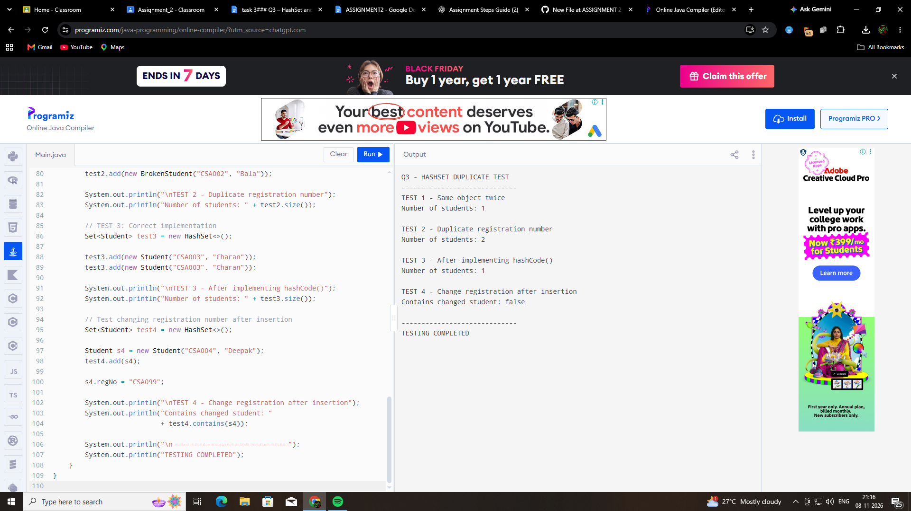

Collection | Main purpose | Typical operation complexity
HashSet | Store unique students | O(1) average add/search
TreeSet | Store unique students in sorted order | O(log n) add/search
HashMap | Store students using registration number as key | O(1) average put/get

